User Manual

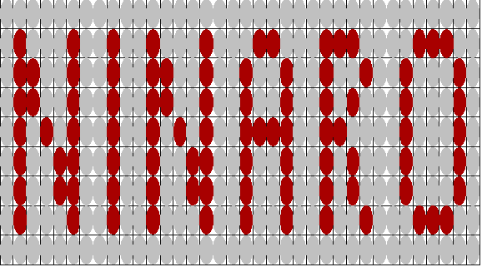

User Manual

Ninaro 3
Installing And Removing Ninaro 3
Installing 3
Removing 3
Game Configuration 3
The Help System 3
How To Use Help 4
Table of Help Keys 4
How To Play 4
Controlling Ninaro 4
Player's Keys 4
Table of Player Keys 4
What The Keys Do. 5
Table of Key Functionality 5
The Mouse 6
Table of Mouse Functionality 6
Other Keys 6
The Menus 6
The Game Menu 6
The Board Menu 7
The Player Menu 7
The Help Menu 7
The Dialogs 7
The Custom Board Dialog 8
The Player Dialog 8
The Player Options Dialog 9
The Game Options Dialog 9
Troubleshooting 10
I don’t want to be YELLOW anymore. 10
My opponent is RED and I want to be RED. 10
I want to play someone else. 10
I want the loser to go first always. 10
I don’t know which move to make, help me decide! 10
The sound is really bugging me, can I turn it off? 10
Someone made the hilite RED, I prefer GREEN! 10
Some really strange things are happening!! 11
The configuration is really bad, I preferred the default one. 11
This black screen is too dull, can I brighten it? 11
I want to print a screenshot, but there is too much black!!! 11
The computer is too slow, can I speed it up? 11
The computer is too fast, can I slow it down? 11
I am addicted to the game. 11
I am totally undefeated, the game is no challenge. 11
Tutorial 12
Typical Game. 12
About Ninaro 12

Ninaro

Ninaro stands for N-in-a-row, which means that the connect four game has been extended to connect any number on any sized grid. Logically however a minimum of 3 rows, 3cols, 3 in a row (3x3x3) applies. All the rules about the game connect-4 still apply. It is still a two player game, one feature of Ninaro being that you can play computer opponents, known as AI’s (Artificial Intelligences).

Installing And Removing Ninaro

Installing
To install the game, copy the install.EXE file from the distribution disk to the directory to which you wish to install it. Ninaro requires hard drive installation. Run the install.exe file. Once it is completed running, the game files will be in the directory.
These files are:
Ninaro.EXE
Ninaro.TTL
Ninaro.HLP

You may delete install.exe if you wish. The game is run by Ninaro.exe. The game can be run either inside or outside a Windows ™ Environment. If it is run outside a mouse driver will need to be installed if you wish to use the mouse.

Removing
Removal is simply a matter of deleting all Ninaro.* files in the directory to which you installed the game.

Game Configuration
The game configuration will be saved when you exit the game, and reloaded when the game is run again. The config saves such things as who is playing, what each players colours are, what size the board is, what size the connect is, and what the player and game options are. Should you become unhappy with the config, you can delete the file NINARO.CFG. The game will generate a default one if none is found.

The Help System

Help can be gained by either using this manual, or from within the game. Help inside the game has the added advantage of being context sensitive: - that is, when you ask for help you will be given help on where you are in the program.

How To Use Help

Press ESC or F1 to exit help. If you used the menu to get help, the keys you used in the menu work here. Otherwise you used F1 or H to get help, and the arrow keys work here. Please ensure that NumLock is off (by pressing the NumLock key on the numerical keypad to the right of your keyboard until the NumLock light is off). The table below shows what these keys do.

Table of Help Keys
Key | Function
Left | Scrolls UP a page
Right | Scrolls DOWN a page
Up | Scrolls UP a line
Down | Scrolls DOWN a line
PageUp | Scrolls UP a page
PageDown | Scrolls DOWN a page
Home | Scrolls to the top of help
End | Scrolls to the end of help

How To Play

The aim of the game is to connect a number of tokens in the grid while stopping your opponent from doing so. The first player to make the connection wins. The number of tokens you must connect to win is shown at the top right of the screen, under the Connect heading. Connections can take place in four different ways, being vertical, horizontal, and the two diagonals. A connection occurs when a token is next to a token of the same type. A win occurs when a number of tokens are connected in this way. When a win occurs, the game prompts you to press Cancel to continue.

Controlling Ninaro

Ninaro is controlled with either the keyboard or the mouse. Only player one can use the mouse while in the game, any player can use the mouse in the menus or dialogs.

Player's Keys

Each player has a set of keys, consisting of Left, Right, Up, Down, Select and Cancel. The table below shows these keys.

Table of Player Keys
Key/Player | Player One | Player Two
Left | A | Keypad 4
Right | D | Keypad 6
Up | W | Keypad 8
Down | S | Keypad 2
Select | E | ENTER
Cancel | Q | BackSpace

The keypad keys can be used as either the grey arrow keys or the numbered keys on the numerical keypad for which numlock must be off.

What The Keys Do.

Depending on where you are in the program, the keys do different things, though they are quite similar. The table below shows the functionality of the keys at each location on the program.

Table of Key Functionality

Key/Location | Playing A Game | Using Menu | Using Dialogs
Left | Token Left | Left a Menu | Left an item
Right | Token Right | Right a Menu | Right an item
Up | Calls the menu | Up an item | Up a group
Down | Drops Token | Down an item | Down a group
Select | Drops Token | Select item | Select Button- OK, Reset, Cancel
Cancel | Calls the menu | Cancel Menu | Cancels Dialog

The Mouse

Only Player One has access to the mouse while playing a game. The following table shows mouse functionality. To enter a token move the mouse to the appropriate column in the grid and press Select (left-click). Obviously using the right mouse button as Cancel calls the menu.

Table of Mouse Functionality

Key | Mouse Action
Left | Move mouse left
Right | Move mouse right
Up | Move mouse up
Down | Move mouse down
Select | Press Left Mouse Button
Cancel | Press Right Mouse Button

Other Keys
F1 or H | Calls for help
F2 | Saves the game
F3 | Loads the game
F10,CTRL-X,CTRL-Q,ALT-F4 | Quits the game
ESC or M | Calls the menu, menu keys are player two’s keys.

The Menus

The menus are the key way in Ninaro of changing things. The menu is accessible at almost anytime by pressing ESC, M for menu, or your appropriate player key.

The Game Menu

The game menu lets you control the game.

New | Starts a new game
Load | Loads the saved game, Load Error appears if no save file found
Save | Saves the game, there is only one saved game
End | Ends the current game, when no game is on all menu options are accessible (e.g. player one and two) dialogs.
Suggest Move | Suggests a move to make. The move is suggested by AI Genius.
Toggle Sound | Toggles the sound On and Off
Options… | Allows you to change the background and hilite colours, and how much use you wish to make of the mouse.
Exit | Exits the game.

The Board Menu

The board menu lets you change the board attributes

7x8x4 | Changes the board to 7 Columns, 8 Rows, Connect 4
12x13x6 | Changes the board to 12 Columns,13 Rows, Connect 6
Custom… | Changes the board via The Custom Board Dialog

The Player Menu

The player menu lets you change the player attributes

One... | Changes the attributes of player one via The Player Dialog
Two... | Changes the attributes of player two via The Player Dialog
Options | Changes the player options via The Player Options Dialog
Reset Scores | Resets both player's scores to zero.

The Help Menu

The help menu provides all your help needs, via this screen. Help is available at anytime by pressing either F1 or H.

Contents | Brings up the help screen, scrolled to the top
About | Brings up the about window

The Dialogs

Dialogs help you choose from a group of options. In the dialogs C cancels, R resets and O ok's. Pressing Select at any time while in the dialog results on the hilited
button (OK,Reset,Cancel) being used, while pressing cancel cancels the dialog.
The options chosen in a dialog only take effect if the OK button is pressed. This means that any number of changes can be made while inside a dialog, but none of these changes will take effect if the Cancel button is pressed. Reset resets the dialog to have the values it had when the dialog was first opened.

The Custom Board Dialog
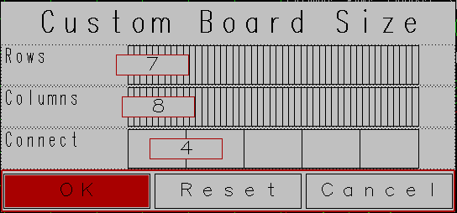
The custom board dialog allows you to change the size of the board and/or the number of tokens which must be connected to win a game. You will notice that an incorrect value can never be selected, as the game size automatically resizes when the number of columns or rows is changed.

The Player Dialog

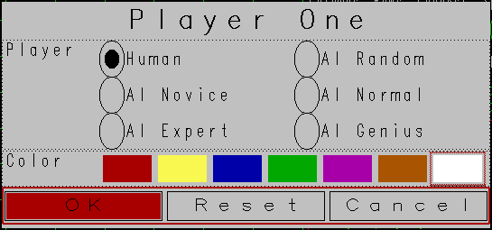
The player dialog allows you to change a player’s colour and/or name. If a player’s name is changed, a new game is started (as a new player has entered the game). If however only a player’s colour is changed, the tokens in the game change colour and the game continues. You will notice that you cannot select the colour that your opponent has. Should you wish to have their colour, they must first change their colour to something else, then you may change to be the colour which is now free.

The Player Options Dialog

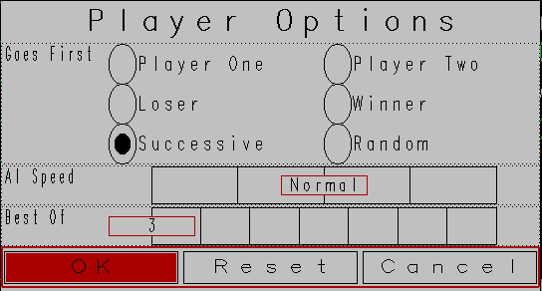
The player options dialog allows the game to be customised to suit your needs. There are six ways that a player may be chosen by to start the game. Players One or Two may always go first, the Loser or Winner of the previous game may go first, the player who went second last game may go first this game (Successive), or a player may be chosen at Random to go first. The AI speed may also be adjusted to suit your needs. If both players are AI’s and the AI speed is set to fastest, the games will proceed without prompting the user to hit escape to continue when a game is run. In this way the game can be set on demo mode.

The Game Options Dialog

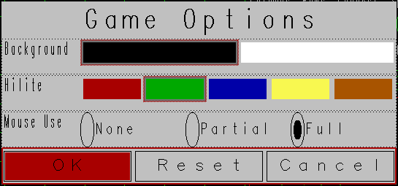
The game options dialog allows you to customise some of the colours used in the game. The background colour can be set as either black or white, and the hilite colour can be selected from a list of colour alternatives. The mouse usage can also be configured here. Due to some problems which were encountered when the mouse feature was added, the mouse is a bit sensitive. If you do not wish to use the mouse ever, or its sensitivity is making its presence felt, you can set the mouse use to None. This sensitivity is least noticed when a player is using the mouse to make a move. The Partial option allows mouse usage only when making a move. The Full option allows the mouse to be used when making a move, and in the menu and dialogs.

Troubleshooting

I don’t want to be YELLOW anymore.
You can change your colour via the Player Options Dialog, which is accessed through the menu from the Player Menu. Should you wish to be the colour that you opponent has, see the next heading.

My opponent is RED and I want to be RED.
You have two options, convince the other player to be another colour and then choose RED, or choose another colour. AI opponents can be very easily convinced, just change their colour.

I want to play someone else.
If you are currently playing a game, Call the menu and use Game->End. Change the other player by using the Player Menu, selecting the opponent (If you are player one, select player two and visa versa). Change the name to someone else, and press OK.
Call the menu again and use Game->New.

I want the loser to go first always.
Call the menu, use Player->Options, and change the Goes First to loser.

I don’t know which move to make, help me decide!
If you are unsure about which move to make, call the menu and use Game->Suggest Move. AI Genius will then move the token to the column in which it would make a move.

The sound is really bugging me, can I turn it off?
The sound can be toggled by Game->Toggle Sound. The current status of the sound can be seen at the top right of the screen under the heading ‘Sound’. If it is On, toggle the sound to off.

Someone made the hilite RED, I prefer GREEN!
The hilite colour can be changed via Game->Options. Change the hilite from RED to GREEN via the dialog which is presented.

Some really strange things are happening!!
The mouse is probably showing it’s sensitivity, use Game->Options to turn the mouse usage to Partial or None. None will totally desensitise the mouse.

The configuration is really bad, I preferred the default one.
Simply delete the NINARO.CFG file which is in the game directory. When Ninaro finds no configuration file, it creates a default one.

This black screen is too dull, can I brighten it?
Yes, you can. You can use Game->Options to change the Background color to white.

I want to print a screenshot, but there is too much black!!!
You can use Game->Options to change the Background color to white. Make your screenshot (hit the Print Screen key under Windows ™), and then change it back to black.

The computer is too slow, can I speed it up?
If the computer is too slow, call the menu and use Player->Options. Change the AI speed to the desired setting.

The computer is too fast, can I slow it down?
If the computer is too fast, call the menu and use Player->Options. Change the AI speed to the desired setting.

I am addicted to the game.
This is probably because you win enough games to make it worthwhile. Make the game harder, refer to the paragraph below for more information. If this is still not a solution, then as the creator of this game I have won!!! Wait for the next version which will have harder opponents.

I am totally undefeated, the game is no challenge.
Try changing some of the following :-
Player->Options->Goes First as Loser
Board->Custom->(Change the connect size). Higher levels of connection are harder to obtain.
Board->Custom->(Change the row or column size). Different boards can have different strategies.
Change your opponent, possibly to an AI.
Play a human. Humans are better in some areas of strategy than AI's. Humans learn from their mistakes.

Tutorial

An important concept about the game is that you need to be in a game to play. If you are in a game you can end it by using Game->End. This then gives you full access to all menu items(except End), meaning you can change both players. Once you are ready to start a game with the options you have selected, use Game->New.

Typical Game.

Gavin and Ronda would like to play a game. The game is currently configured as Player One vs AI Genius. They are playing a game. Ronda calls up the menu by pressing ESC, uses Game->End. She then calls up the menu and uses Player->Two.
She changes the player to Human and presses OK. She then calls up the menu and uses Game->New. The game is on. Orville walks into the room, and Ronda asks him to play for her. Gavin agrees. Orville looks at the screen, Gavin is GREEN and Ronda is Red. He says –‘all the tokens are the same colour!!’. Gavin, realising that Orville is RED-GREEN colour blind, calls up the menu and uses Player->Two. He changes Orville’s colour to ORANGE. They then proceeds as though nothing had happened. All the RED tokens are now ORANGE, but the game is still going.
Later on, Orville realises the reason he is losing is because Ronda was losing when he took over. He calls Gavin’s attention to this, and the call up the menu and use Player->Reset Scores. They now have zero games each won, and can fairly play again. Gavin Wins a game. Orville, seeing where the connection had occurred, presses Cancel and they continue.

About Ninaro

Ninaro was written by the author in 1998, as a university project.

